National Association of Peer Program Professionals
National Peer Helpers Appreciation/Recognition-Day/Week Resource Kit

Week of March 21 – March 25, 2016
Table of Contents

Part 1: National Peer Helpers Appreciation/Recognition-Day/Week Kit

- NAPPP Peer Helpers Appreciation/Recognition Resource Kit Overview
- Event Step by Step Guide
- Action Plan Worksheet
- Recognition Activities Ideas
- Media Guidelines
- Sample Proclamation for school, newspaper and local/state government

Part 2: Logo and Media Samples and Templates

- NAPPP Official Logo
- Sample Proclamation
- Sample Media Posts

Part 3: Overview of Peer Helpers Appreciation/Recognition Day/Week

Peer Helpers Appreciation/Recognition Day/Week:

YOU know you are doing great things in your school and community when …
YOU know you are working hard to help your peers when …
YOU know you are helping younger youth when…
YOU know that your peer helper skills make for a positive school climate when…
YOU know your work makes a difference when…
Helping others one person at a time …
National Peer Helpers Appreciation/Recognition Day/ Week takes one day/week out of our busy year for schools and communities with Peer Helping classes/groups all over the world to CELEBRATE YOU and all that you do.
This Resource Kit offers easy ways to celebrate NAPPP Peer Helpers Appreciation/Recognition Day/Week in your school or community. NAPPP Peer Helpers Appreciation/Recognition is built around fun activities, and getting others to sign off on your proclamation.
NAPPP National Peer Helpers Appreciation/Recognition Day/Week is March 23, 2016. It can be celebrated one day or all week. The theme, NAPPP National Peer Helpers Appreciation/ Recognition Day/Week, leaves lots of room for creativity, and we want you to have fun while you’re making your point. We’ve created some ideas to get started and you can go crazy with your own additions, but all peer programs should include the following:

- Hold an activity at school or in the community
- Get the administrator or community leaders to sign off on the proclamation
- Wear your Peer Helper T-Shirt or other gear
- Celebrate what you do
- Take pictures and share them with us and your local media and NAPPP newsletter---e-mail: nappp@sbcglobal.net of post to our Face book page

That’s it!!
So let’s get started!

Part 1: Events

Choose a NAPPP Peer Helpers Appreciation/Recognition- Day/Week Activity

Getting Ready For Your Week-Preparation

Advance planning can make your activities the best it can be. Follow these steps, and you’ll have the best chance of success!
Look for other Peer Programs in your school district and community
Are there other peer programs in your district, city or county? If so, it will be better and easier for nearby Peer Program to work together to put on one big activity rather than compete for resources. To find other state or county peer programs, please contact us at email: nappp@sbcglobal.net
Create a Planning Committee
The dedication, enthusiasm, and abilities of the people who work on your activities contribute significantly to its success. The committee can consist of peer helpers, peer program professionals, stake holders, school administrators and parents, or anyone that is committed to Peer Helping.
Set the Date
National Peer Helpers Recognition/Awareness-Day/Week is March 23, but you will need to select the time of the activities. If that date conflicts with other activities, set a better date for you. Check with your school administration, town officials, and other community members to see if there are other large group events already being planned that may conflict with your National Peer Helper Recognition Day/Week.
Obtain a Proclamation
You may want to obtain an official proclamation from local/state government leaders declaring the week of March 23 NATIONAL PEER HELPERS RECOGNITION DAY/WEEK in the jurisdiction. A proclamation can help convince the media to cover your event. Getting a proclamation can take several weeks, so this should be one of the first things you do! A guide for obtaining proclamations can be found with these materials. You’ll also want to invite local officials to the local activity, perhaps to present the proclamation during the event. Be sure to inform your legislators about the wonderful work that Peer Programs have been doing for over 35 years. Remember that elected officials are always looking for opportunities for photos and press coverage, and so discuss the ways your program can work with the media to publicize this event. With a little hard work, you can establish a relationship that will help your peer program in the future.
Select a Site
You need to find a location to hold the activities. This could be indoors at your school, school board meeting, a community center, or the town or city hall, or, if you plan a walk, outdoors at a public park or school athletic facility. Be prepared with a podium and chairs, if that is part of your ceremony.
Invite Guests
Your activities can be a community event. Besides the school community, you may want to invite others who are interested in peer program issues, such as reducing underage drinking and drug use, reducing conflict, increasing academic skills, reducing harmful behavior in others, reducing bullying. Reach out to local elected officials, mental health professionals, law enforcement officers, firefighters, emergency room nurses and doctors, the National Guard, prosecutors, judges, auto insurance agents, substance abuse counselors, community coalition members, and other youth groups and parents.
Look for Resources
Putting on a proper event can be a challenge without donations. If you plan to offer refreshments, you might ask local grocery stores, bakeries, or restaurants to donate goods for the event. Perhaps you’d like music–you can ask a local radio station or DJ to offer their services. You could also ask local businesses to sponsor the event or donate funds to your program. For more details on soliciting support, see the suggestions in this guide.
Plan publicity
Your Peer Helper Recognition activities will not be successful unless people are aware of it. Will you send invitations to guests and others? Distribute fliers around town to notify the public? We also suggest you work closely with the media. See the Media Tools section for step-by-step instructions on what to do.
Create a timetable
A step-by-step timetable that includes every task that needs to be done when and by who will be helpful.
Wear your Peer Program T-Shirt and other Gear
Your Peer Program logos and messages will be an important part of any news story and photographs. Plus, we want you to post your photos on our sites so you can see what other Peer Helpers across the world are doing.

Other useful planning tips
____Develop a written program to hand out at the event.
____Designate someone to be the event photographer.
____ Make copies of the proclamation.
____Create handouts, awards, certificates or plaques, as needed.
____Designate a setup crew for your activity.
____Designate a cleanup crew for your activity.
____Send thank you notes to everyone involved in your activity.
____Celebrate your success in completing the activity in some way.
It’s a good idea to schedule a post-event evaluation with your Peer Program and other key people to share what worked well and what didn't. This evaluation will provide you with valuable lessons for next year’s activities. Make it better and better every year!

Activities
An activity can be …
- An assembly
- A ceremony
- A fair that focuses on all the services you offer through posters or videos
- A party (with a cake!) or a dance
- A walk—in a park, around a pond, around your track, thru your town
- A poster contest
- An awareness activity with younger youth

NAPPP National Peer Helpers Appreciation/Recognition Week/Day will raise awareness in your school and your community about all the things that you do to make your school/community a healthier place. You can use the activities to …
- Share what young peer helpers do to help others
- Give recognition to those peer helpers who are leaders and the professional staff who help you
- Raise funds for your peer program or another cause in your community
- Hold a retreat for peer helpers to learn new skills and celebrate your program
- Share your successes with your stakeholders (Stories & Data)
- Introduce younger students to the importance of peer programs
- Develop a video about your peer program
- Read a proclamation from your governor, your mayor, your city council, your school board, your student government, or your superintendent (See sample)

NAPPP National Peer Helpers Appreciation/Recognition Week/Day will raise awareness in your school and your community about all the things that you do to make your school/community a healthier (better) place. You can use the activities to …
- Share what young peer helpers do to help others
- Give recognition to those peer helpers who are leaders and the professional staff who help you
- Raise funds for your peer program or another cause in your community
- Hold a retreat for peer helpers to learn new skills and celebrate your program
- Share your successes with your stakeholders (Stories & Data)
- Introduce younger students to the importance of peer programs.
- Develop a video about your peer program
- Read a proclamation from your governor, your mayor, your city council, your school board, your student government, or your superintendent (See sample)
Ceremony
A ceremony for your school board meeting may be helpful to share your successes. You will find a sample script later in this resource kit, the positive changes we have made over the years with ourselves and others. You might choose to honor the peer program adult professionals in your community who help you be successful by introducing each one, saying what each has done, for each person honored. At the end of the ceremony, everyone can be asked to say someone who has helped them in their life. You can have a ceremony where everyone lights a different color candle celebrating your past, present and the future of your program.
Walk
Besides a ceremony, you can include a walk. This kind of walk can be a celebration of lives helped and saved. We recommend walking while wearing t-shirts and other peer helper gear. Invite others to walk with you. The walk could be a way to raise funds for a local cause or your program.

Have a party, invite the family!
You can turn your event into a fun fair with activities. You can include cake and ice cream, and punch for parents and siblings. Have a program that highlights the activities of your peer program. Focus on all the positive things your peer program has done in your school and community. Peer Helpers share how the program has helped them.
Go to the School Board Meeting, Capitol or Town Hall
You can attract significant attention to National Peer Helpers Appreciation/Recognition Day/Week by obtaining a proclamation. Your Peer Program Professional will assist you in getting a proclamation from your state, local governments, and school board. A sample proclamation is included in this resource kit.
Put your activities on the school TV channel or other school social media
Put information on your school TV channel about the Peer Helper Activities and how to become a peer helper. We have put together some tools to help you make your event successful. The documents in this resource kit include:
- Script for a ceremony–you can edit this to emphasize youth achievements, honoring peer helper leaders and adult professional staff
- Draft proclamation recognizing National Peer Helpers Recognition/Awareness Day/Week (start early!)
- Draft press release–make sure to share your work. You deserve the credit!
- Draft tweets, posts and PSAs–remember to celebrate all week, leading up to March 21.

Wear your Peer Program T-Shirt and Gear
This is Peer Helpers Appreciation/Recognition Day/Week so be sure to wear your Peer Program t-shirts, hoodies, hats, and other gear. You want people to know how proud you are to be part of “Peer Helping Peers”. Your Peer Helpers Appreciation/Recognition Day can be a recruiting tool for your program, making students aware of all you do in your school and community. Make sure that any photos you take include the NAPPP logo or your local peer program logo.

Celebrate
Remember that the National Peer Helpers Appreciation/Recognition Day/Week is a celebration of all the positive things that you do, so keep the outlook shiny, upbeat, and positive. Even if your activities include issues that youth face and how much they need peer helping to help save lives. You have a lot to be proud of and you deserve the applause. This is your day!

Share Your Program Story
You can get major recognition for your program by publicizing these activities in advance, and then by documenting your success (stories and data). Build excitement by tweeting and Facebook posting about the activities in advance. Remember that you are part of an international movement for over 35 years of young people making good choices, being a healthy role model and helping other youth, so remind people of the good things your Peer Program does. We have included many sample tweets and posts that you can use or make up your own. You can also make announcements on your school’s PA system, adding data or stories about the work that you have done in your school or community.
On the day/week, we want to see what you are doing in your school. Remember to wear your
Peer Program t-Shirt and other gear! Take a selfie with your gear and post it on Instagram or send your photos to NAPPP so that we can put them on our Facebook page. Remember, part of the excitement of this day/week is that there are thousands of programs across the world. We want the public to see all of the work that peer helpers do on this special day/week.
We have also included templates of press releases for you to use for your event. Make sure that your local media knows about the National Peer Helpers Week/Day. This is a time to showcase all of the good things that peer helpers are doing! Call your local paper in advance and encourage them to send someone to cover it. If you have a TV station in your area, make sure to tell them about the all the good work peer helpers do! If the media is unable to make it to your activities, send them your best picture, along with a caption. You deserve your day to be PUBLICIZED!

Action Plan

Use this worksheet as the start of your planning for your Peer Helpers Recognition Day/Week! As you hear people present ideas, write down those that you think might work for your chapter.

Question 1: Who should you invite to your event? Make sure to think about why you should invite a given group or individual.

Question 2: What fun elements could be part of your activities, beyond the speakers and ceremony?

Question 3: How can you promote the activities? Think of not only media attention, but how you can promote this to the public on your own as well.

Media Guidelines
Here you’ll find information about helpful social media messaging and template resources to let the world know about your Peer Helpers Recognition Day/Week. Toot your horn!

Social Media/Key Messaging
Use the sample tweets and posts provided or create your own. Leading up to National Peer Programs Recognition Day/Week, get the excitement going by creating a buzz! Create your messaging as needed. Tweet twice a day and post pictures on Facebook and Instagram!

In-House PA or TV System Announcements
Use the template announcements provided or reinvent them! A sample script may be used for in-school public address announcements. Some schools might use them as text on monitors or in video announcements.

Public Service Announcements
Use the template PSAs provided and customize them as needed. These are the typical 30 second spots and some 10 second spots, in case the station has a small window of time to fill. See Peer Resource Program sample video (Peer Resource.org)

Traditional Media Outreach
Be sure to put each on your school’s letterhead. Consider dropping these off in person.
If any media outlet covers your event, a handwritten thank you note will go a long way in helping your peer program, stand out from the crowd, and may encourage the media contact to cover future peer program activities. This is a great way to start or continue building relationships with your media contacts.

Letter to the Editor
Customize the template letter to the Editor and have the principal sign it. Letters to the Editor must have an address associated with them, so again, be sure to put your media tools on school stationery.

News Release
Customize the template news release provided and send it out the day prior to or morning of your activity.

Photos & Captions
If the media is unable to cover your event, don’t lose heart. Choose your best picture, add an informative caption and send it to your local weekly and daily papers. Your caption should include your peer program name and identify the people pictured, unless this is a large-group image. Add a photo credit line with the photographers name as well. There’s a good chance these images and captions will get picked up.

Post-Event Recognition
Everyone loves being thanked and appreciated! Don’t forget the media who cover your event. Send them a handwritten thank you note. Impress them with your follow up, your professionalism and sense of courtesy. This will enhance your chance of this media outlet covering future activities.

Ceremony
This section of the guide offers a start-to-finish example of what you might do for an actual Peer Helper Recognition Ceremony. Remember – this is only a suggestion.

welcome/Opening
In promoting the activity, especially to local school board, officials and the media, explain what time people will begin to arrive and when the actual speaker/ceremony portion of the event begins. At the start of the Recognition Ceremony, post signs to direct people to the activity. You can hand out programs about the activity at this point or when the program starts. You may wish to have people sign a guest book so you can reach out to them in the future.
If you’ve chosen to offer refreshments, this would be the time. You might simply offer light snacks, cake, ice cream, and drinks or have pizza. Consider seeking donations from local grocery stores, bakeries, or restaurants to provide these refreshments.
While people mingle and enjoy refreshments, you might have posters or a video showing what peer helpers do at your school or community.

Speakers
Gather the audience at the front of the room where you have chairs and a podium set up. Get everyone seated.
Begin with having a Peer Helper student welcome everyone and thank those who helped put the ceremony together, including local officials, facility managers, local businesses who donated to the event, and parent or teacher volunteers. The student should then talk briefly about Peer Helpers successes for the year. Emphasize the great work your peer helpers have done. Finally, address the challenges that still remain.
After the Peer Helper speaker, invite local administrator and other dignitaries to speak. Elected officials can read the proclamation, if one has been issued. Most local officials will want to speak if they attend. You’ll want to limit the allotted time per speaker to keep the event on track and moving.

NARRATOR: We would like to honor our past peer helpers in our school/community and all the great work they have done. Now we would like to celebrate the services and help this year that our peer helpers have done such as conducting mediation, tutoring students, presenting lessons on bullying prevention, etc. Our peer helpers have reached over 4,000 (?) other youth this year. We now would like to vision the future of Peer Helping and the future of helping others.
The National Association of Peer Program Professionals was founded in 2009, prior to that it was known as the National Association of Peer Programs and prior to that it was known as the National Peer Helpers Association. Since the founding of NAPPP, the National Programmatic Standards and Ethics have been developed that guides programmatic development and training of peer helpers. Peer Program Educators have been certified for the Adult Professionals and Peer Programs have been certified internationally. NAPPP Trainer/Consultants have been recognized.
STUDENT 1: I light this candle to honor past peer helpers.
NARRATOR: Addressing the problems of conflict, relationship issues, bullying, low academic skills, poor health habits, substance abuse, and mental health issues, NAPPP believes that peers helping peers are effective in helping others feel connected, increase self-esteem, drive safely, promote healthy life styles and safer schools and communities.
[The same format is followed. Another student steps forward, places a different color candle and lights it]

STUDENT 2: I light this candle to celebrate our current peer helpers that save lives and create healthier and productive peers.

[The student then moves to the side, and the same format is followed as the narrator addresses other issues.]

NARRATOR: Although alcohol is the number one drug abused by teenagers, illegal drugs and misused prescription drugs remain a great threat. Peer Helpers work to reduce youth use of illegal drugs, reduce conflict, increase academic skills, promote healthy behavior ,and teach social skills to other youth.
STUDENT 3: I light this candle to vision our future to commit to helping others in the future.
NARRATOR: In addition to addressing issues that our peers face, we are committed in the future to assist youth with whatever issues arise.
(You may want to highlight what issues your program addresses and add as issues to Student 2)
NARRATOR: Thank you. At this moment, across this state, county, and the world, other peer programs are gathering in ceremonies like this. We’re all honoring our past successes, celebrating our current successes and visioning the future.
NARRATOR: Thank you for joining us in this ceremony. We come from different backgrounds and have different opinions and views. We all bring different perspectives and skills to solving the problems. Working together, we can help other youth.
(If media are present, you can ask them if they would like the group to have a picture together. The narrator should then thank the audience for attending, encourage people to mingle, and enjoy more food and music.]

Follow-up

- Write thank you notes
- Debrief with planning committee - what went well and what could have gone better
- Send pictures and stories to NAPPP - email: nappp@sbcglobal.net

NAppp logos

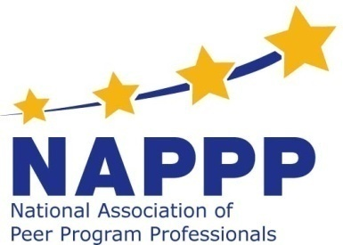
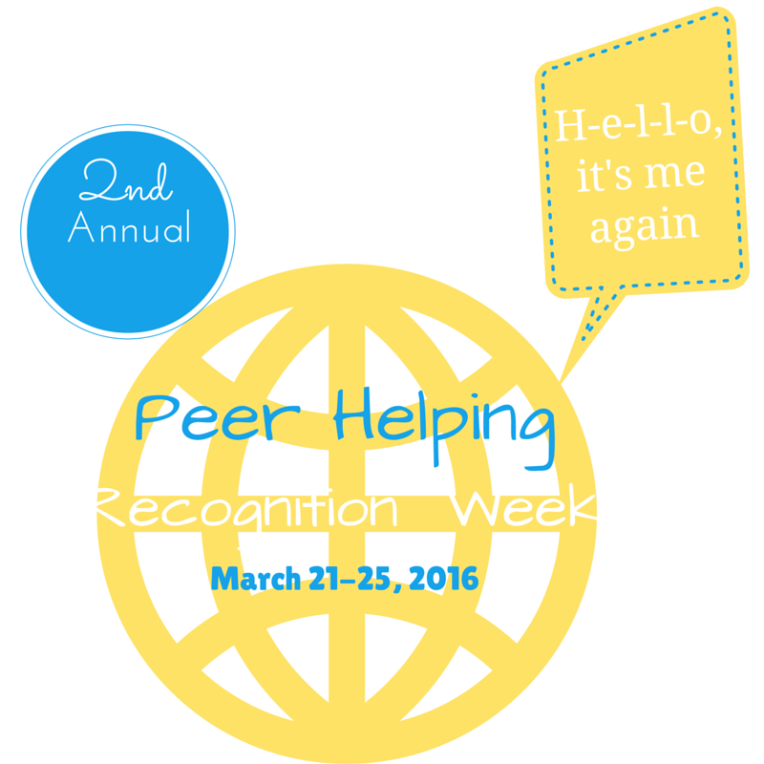

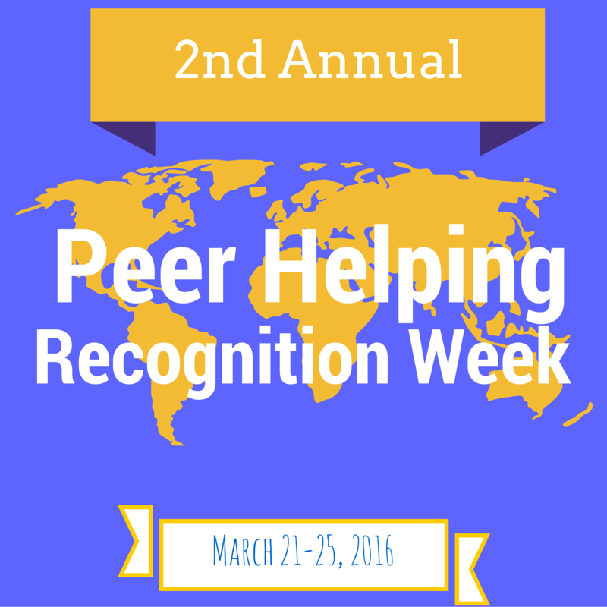

Sample Proclamation
RESOLUTION ON THE OCCASION OF NATIONAL PEER PROGRAMS DAY/Week
WHEREAS, THE NATIONAL PEER PROGRAMS WEEK IS TO BE HELD MARCH 23-27.
WHEREAS, PEER PROGRAMS HELP YOUNG PEOPLE IN (INSERT COMMUNITY) AND THROUGHOUT THE WORLD MOBILIZE TO ADDRESS THE ACADEMIC AND SOCIAL NEEDS OF FELLOW STUDENTS AND HAVE EMERGED AS A RECOGNIZED AND DYNAMIC FORCE IN OUR COMMUNITY; AND
WHEREAS, PEER PROGRAMS PROVIDE YOUTH WITH OPPORTUNITIES FOR LEARNING, GUIDANCE, EMOTIONAL SUPPORT, AND GROWTH WHICH TRANSLATES TO REDUCED DRUG AND ALCOHOL INVOLVEMENT, HIGHER ACADEMIC SKILLS, REDUCED HIV/AIDS, AND UNWANTED PREGNANCY, REDUCED CONFLICT, REDUCED BULLYING, INCREASED UNDERSTANDING OF DIFFERENCES, AND INCREASED SERVICE TO OTHERS. BY HELPING OTHERS, PEER HELPERS OFTEN INCREASE THEIR OWN SELF-ESTEEM AND PERSONAL FUNCTIONING, AND
WHEREAS, THROUGH RESEARCH AND EVALUATION, PEER PROGRAMS HAVE BEEN FOUND TO BE ONE OF THE MOST PROVEN AND EFFECTIVE PREVENTION STRATEGIES, AND
WHEREAS, PEER PROGRAMS ARE AN EXAMPLE OF HOW SERVICE TO OTHERS IS A FOUNDATION FOR POSITIVE GROWTH AND CHANGE; NOW THEREFORE BE IT
RESOLVED, THAT THE (INSERT COMMUNITY NAME HERE) CONGRATULATES THE (NAME OF SCHOOL) PEER PROGRAM FOR THEIR DEDICATED SERVICE UPON THE OCCASION OF NATIONAL PEER PROGRAMS WEEK AND EXTENDS TO THEM ITS SINCERE BEST WISHES FOR CONTINUED SUCCESS; AND BE IT FURTHER RESOLVED, THAT A COPY OF THESE RESOLUTIONS BE TRANSMITTED FORTHWITH BY THE CITY TO THE (NAME OF SCHOOL).

Sample News Release
NAPPP National Peer Helpers Appreciation/Recognition Day/Week

Media Template: News Release
To be customized, printed on school letterhead and dropped off or sent to the news desk and/or managing editor of your local weekly and daily print media the day before or on the day of your event. Post a release on your school’s website as well!
FOR IMMEDIATE RELEASE CONTACT: [NAME]
[DATE] [PHONE]
[EMAIL]

[NAME OF SCHOOL] Recognizes Peer Helpers and wants to thank them for all they do to help others!
Peer Helpers celebrate the peer power---
Making a difference in their schools and communities

[NAME OF SCHOOL] Peer Helpers will join thousands of their peers across the country on MARCH 23, as National Peer Helpers Appreciation Day to recognize all the work the peer helpers do for their schools and communities.
“Peer helping was founded on the principle that ' young helping youth' are important to save lives, enhance positive development and be a role model to younger youth,” stated [LOCAL SADD SPOKESPERSON’S NAME AND TITLE]. “Peer Helpers have been creating positive change in many ways. From mentoring younger students to serving as positive role models, tutoring, mediating, educating, engaging in community service projects and advocating for change in our schools, communities and states, Peer Helpers exemplify and celebrate peer helpers and positive youth development,” added [LAST NAME].
[NAME OF SCHOOL] Peer Helpers will be recognized at the celebration on Monday evening at the school board meeting. Peer Helpers will honor past peer helpers, celebrate current activities and vision the future. [DESCRIBE YOUR PEER HELPING ACTIVITIES AND THE PROPOSED IMPACT OF THESE ACTIVITES.]
“NAPPP NATIONAL PEER HELPERS APPRECIATION DAY/WEEK focuses the country’s attention on the assets young people have in creating meaningful change in their personal lives, peers lives, schools, and communities across the country,” stated Peer Helper Coordinator “. Together, with the many caring adults who have helped guide the work, thousands of young lives have been saved and changed. This peer power last long into the future.
To learn more about [NAME OF SCHOOL] Peer Helpers, visit [INSERT WEBSITE URL] and follow us on [LIST ANY SOCIAL MEDIA PLATFORMS]. You may also go to the national website at www.peerprogramprofessionals.org.

Social Media/Key Messaging

Pre-National Peer Helpers Recognition Day — Get the excitement going; create a buzz!

Sample Tweets:
Use #NationalPeerHelpersWeek
Twitter/Sample tweet in February
Because of YOU National Peer Helpers Appreciation Day is a national day to raise awareness about the peer power as a way to help others and save lives. #NationalPeerHelpersWeek
March 23 is National Peer Helpers Appreciation Day and our school is celebrating by [fill in the blank].

Celebrate Peer Helpers helping for others on March 23.
Peer Helpers help others by being their friend, tutoring, educating. Join in on March 23
Join Peer Helpers around the country on March 23 and celebrate peer power and making a positive difference in other's lives.
Celebrate with us! Peer Helpers honors past peer helpers who have made a difference in others' lives.

Facebook
If you haven’t already posted photos, news items, and any activities on the NAPPP Facebook page, please send those via email to: nappp@sbcglobal.net and make sure to post them on your peer helper Facebook page as well.
Sample Chapter Facebook posts:
Late February Posts
March 23 is National Peer Helpers Recognition Day. We are celebrating past Peer Helpers and all they did to help others, current Peer Helpers and future Peer Helpers.

Instagram

Upload pictures on Instagram; be sure to add Congratulations Peer Helpers!
Remember to upload a photo of your Peer Helper Group wearing Peer Helper t-shirts.

Thank you for participating in this event!!

National Association of Peer Program Professionals Board of Directors

